

Lab Experiment – 08
Depth-First Search (DFS)

Aim
To implement the Depth-First Search (DFS) algorithm for graph traversal.

Objective
To traverse all the vertices of a graph using the Depth-First Search (DFS) algorithm.

Algorithm
- Start with the source (starting) vertex.
- Mark the starting vertex as visited.
- Visit the current vertex.
- Select an unvisited adjacent vertex.
- If an unvisited adjacent vertex exists, recursively visit it.
- If no unvisited adjacent vertex exists, backtrack to the previous vertex.
- Repeat the process until all vertices have been visited.
- Stop.

FlowChart
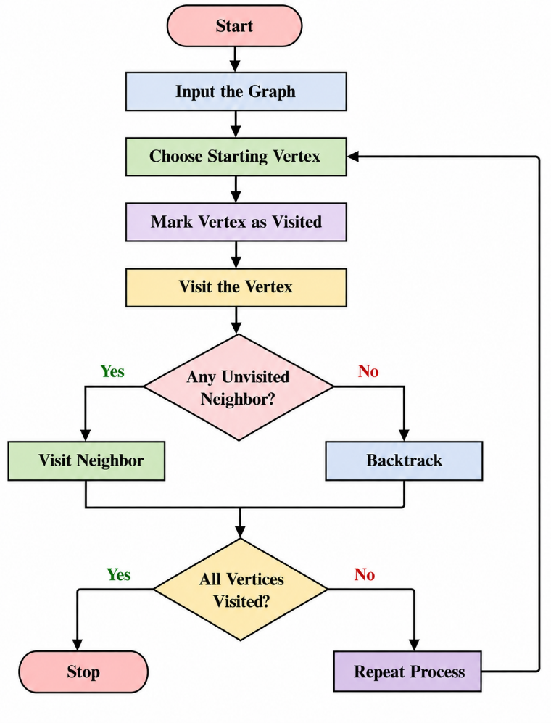
Code
graph = {
'A': ['B', 'C'],
'B': ['D', 'E'],
'C': ['F'],
'D': [],
'E': ['F'],
'F': []
}

visited = set()

def dfs(vertex):
if vertex not in visited:
print(vertex, end=" ")
visited.add(vertex)

for neighbor in graph[vertex]:
dfs(neighbor)

print("DFS Traversal:")
dfs('A')
Output
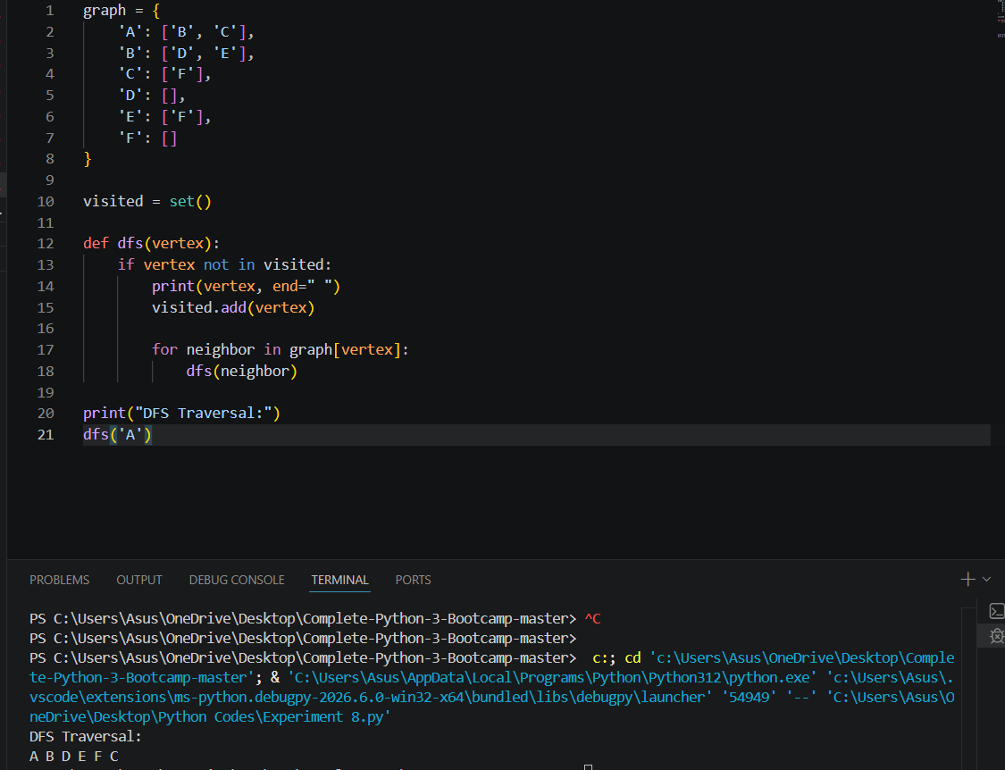

Result
The Depth-First Search (DFS) algorithm was implemented successfully, and all the vertices of the graph were traversed using depth-first traversal.

Conclusion
The DFS algorithm visits a graph by exploring as far as possible along each branch before backtracking. It uses recursion (or a stack) and is useful for graph traversal, path finding, and solving search problems.

